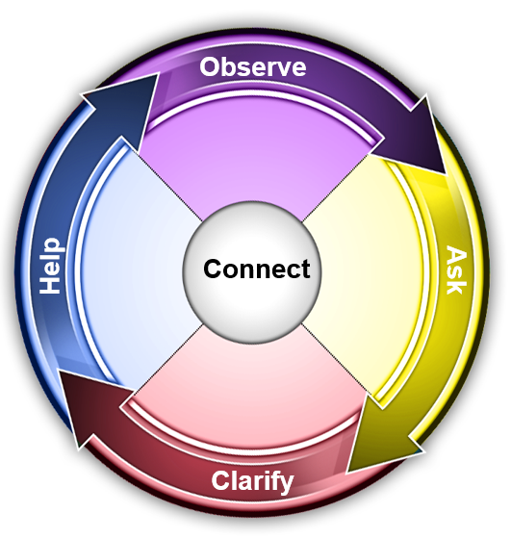

|  |
| --- |
| **Instructions:** Think of someone to provide coaching (for example, an employee who is doing well and you want to reinforce their performance; an employee who needs guidance on a task; an employee you’d like to provide developmental feedback.) Then, enter information on this planner to help guide your coaching conversation.  **Your Name:** Enter your name  **Date:** Click down arrow to select  **Who:** Type person’s name  **Person’s Probable Style**: Click down arrow to select  **Person’s Style-based Strengths:** Enter strengths  **Purpose of Conversation:** Enter purpose |

|  |  |
| --- | --- |
| **Connect** | **What are the links** **to** **conversations, situations, motivators or Communication Style?** Enter links |
| **Observe** | **What actions, behaviors, and/or team dynamics have you observed?**  Enter observations |
| **Ask** Questions | **What is your perception of how things have been going? What questions can you ask to gain a better perspective on this?** Enter perceptions and questions  **What areas did your employee do well?** Enter what employee did well  **What areas would you like to see changed, and what are some ideas for different actions/behaviors? (Provide after asking your employee for their perspective.)** Enter change areas and ideas |
| **Clarify** Expectations and Plan | **What are your expectations and what questions can you ask to determine their expectations?** Enter your expectations and questions to ask  **What plans would you like your employee to take? What questions can you ask to help them determine their plans?** Enter employee’s potential plans and questions |
| **Help** and Support | **How can you help and support your employee?** Enter how to help and support |

